**## Guide is related to Laravel version 11**

**Step 1: Creating the project,**

**laravel new realtime-laravel-basics**

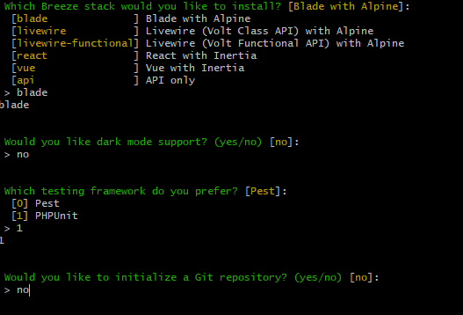

**Step 2: Installing broadcasting,**

php artisan install:broadcasting

After a successful install, resources->js er under e ekta echo.js naam e ekta file create hobe and .env teo change ashbe,

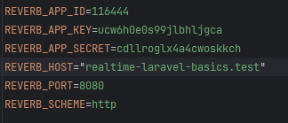

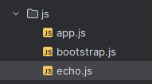

**Step 3**: starting server**,**

**php artisan reverb:start**

**## Joining Channels and events**

**Step 4: npm run dev**

**Step 5: php artisan reverb:start --debug** [eta step 3 ke close kore run korte hobe]

**Step 6:** Ekta event create kora holo,

php artisan make:event Example

************* Step 4 and 5 on thaka lagbe always *************

Ekhn **events->Example.php** er moddhe ekta channel create kora holo,

public function broadcastOn(): array  
{  
 return [  
 new Channel('chat'),  
 ];  
}

Full Example.php code, adding **“ShouldBroadcastNow”**

<?php  
namespace App\Events;  
use Illuminate\Broadcasting\Channel;  
use Illuminate\Broadcasting\InteractsWithSockets;  
use Illuminate\Contracts\Broadcasting\ShouldBroadcastNow;  
use Illuminate\Foundation\Events\Dispatchable;  
use Illuminate\Queue\SerializesModels;  
  
class Example implements ShouldBroadcastNow  
{  
 use Dispatchable, InteractsWithSockets, SerializesModels;  
  
 public function __construct()  
 {  
 //  
 }  
  
  
 public function broadcastOn(): array  
 {  
 return [  
 new Channel('chat'),  
 ];  
 }  
}

Ekhn **dashboard.php** te **x-init** add kora holo, **x-init** er kaj hocche simply js code lekha jay code er moddhe,

<div class="p-6 text-gray-900"  
 x-init="  
 Echo.channel('chat').listen('Example',(event)=>{  
 console.log(event)  
 })  
 "  
>

* Ei example e Echo use kore channel ke listen kora holo
* Ekhn <http://127.0.0.1:8000/broadcast> ei route jeta te broadcast er event chilo, ei link e click korle trigger hobe publicly, cause channel ta hocche public route er.

**## Adding data to events**

Ekhon data ke jevabe broadcast korte hoy,

From **web.php**,

Route::get('broadcast', function () {  
 broadcast(new \App\Events\Example(\App\Models\User::*find*(1)));  
});

From Example.php, just etuk ei change kora,

public function __construct(public User $user)  
{  
  
}

* Ekhon <http://127.0.0.1:8000/broadcast> ke hit korle console e emn output paoa jabe,

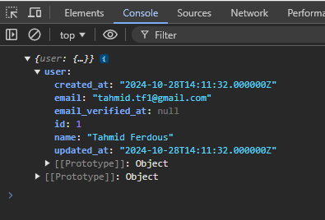

**## Customizing broadcast event data**

broadcastWith() er kaj ta hocche bradcast kora message ta, but direct __construct method er through te hobe na,

public function broadcastWith(): array{  
 return [  
 'id' => $this->user->id,  
 'name' => $this->user->name,  
 ];  
}

Full Example.php snippet,

<?php  
namespace App\Events;  
use App\Models\User;  
use Illuminate\Broadcasting\Channel;  
use Illuminate\Broadcasting\InteractsWithSockets;  
use Illuminate\Contracts\Broadcasting\ShouldBroadcastNow;  
use Illuminate\Foundation\Events\Dispatchable;  
use Illuminate\Queue\SerializesModels;  
  
class Example implements ShouldBroadcastNow  
{  
 use Dispatchable, InteractsWithSockets, SerializesModels;  
  
 public function __construct(protected User $user)  
 {  
  
 }  
  
 public function broadcastWith(): array{  
 return [  
 'id' => $this->user->id,  
 'name' => $this->user->name,  
 ];  
 }  
  
 public function broadcastOn(): array  
 {  
 return [  
 new Channel('chat'),  
 ];  
 }  
}

* __construct() method er data ekhane fully protected state e ase, publicly accessible na.

Now adding a new model named **Message**, for project purpose,

php artisan make:model Message -m

Ekhon web.php route e 2nd parameter post kora holo and contructor and broadcastWith() method er majhe pathano holo data gula ke,

web.php code,

Route::get('broadcast', function () {  
 broadcast(new \App\Events\Example(User::*find*(1),Message::*find*(1)));  
});

Full Example.php code,

<?php  
namespace App\Events;  
use App\Models\Message;  
use App\Models\User;  
use Illuminate\Broadcasting\Channel;  
use Illuminate\Broadcasting\InteractsWithSockets;  
use Illuminate\Contracts\Broadcasting\ShouldBroadcastNow;  
use Illuminate\Foundation\Events\Dispatchable;  
use Illuminate\Queue\SerializesModels;  
  
class Example implements ShouldBroadcastNow  
{  
 use Dispatchable, InteractsWithSockets, SerializesModels;  
  
 public function __construct(protected User $user, protected Message $message)  
 {  
  
 }  
  
 public function broadcastWith(): array{  
 return [  
  
 'user' => [  
 'id' => $this->user->id,  
 'name' => $this->user->name,  
 ],  
 'message' => [  
 'message' => $this->message->id  
 ]  
 ];  
 }  
  
 public function broadcastOn(): array  
 {  
 return [  
 new Channel('chat'),  
 ];  
 }  
}

* Notice broadcastWith() er moddhe data gula ke array kore pathano hoise, output snippet,

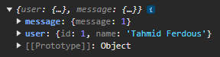

**## Namespace Events**

Suppose directory base e event create holo folder er moddhe like controllers. Tahole Echo diye kaj korar shomoy full path value ta evabe bole dite hobe,

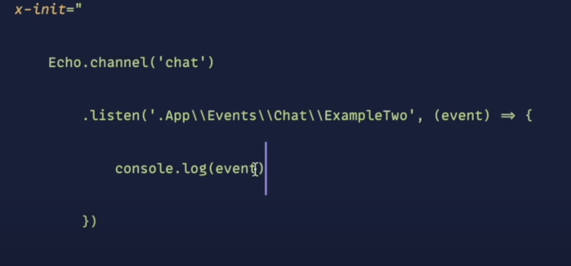

**##Queued Events**

By default e queue setup korai thake Laravel 11 veresion e, just run the command. Eta hocche jokhon amra **ShouldBroadcast** mode e rakhbo



php artisan queue:work